Chapter 3, Solution 61

Calculate the current gain i_{o}/i_{s} in the circuit of Fig. 3.105.

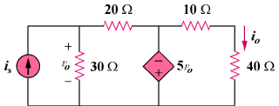

Figure 3.105
For Prob. 3.61.

Solution
+
v₀
–

20 Ω

v₂
+
–

i_{s}

v₁

30 Ω

40 Ω

10 Ω

5v₀

i₀

At node 1, i_{s} = (v₁/30) + ((v₁ – v₂)/20) which leads to 60i_{s} = 5v₁ – 3v₂ (1)

But v₂ = -5v₀ and v₀ = v₁ which leads to v₂ = -5v₁

Hence, 60i_{s} = 5v₁ + 15v₁ = 20v₁ which leads to v₁ = 3i_{s}, v₂ = -15i_{s}

i₀ = v₂/50 = -15i_{s}/50 which leads to i₀/i_{s} = -15/50 = –0.3

